YORKSHIRE 2019 UCI WORLD CYCLING CHAMPIONSHIPS

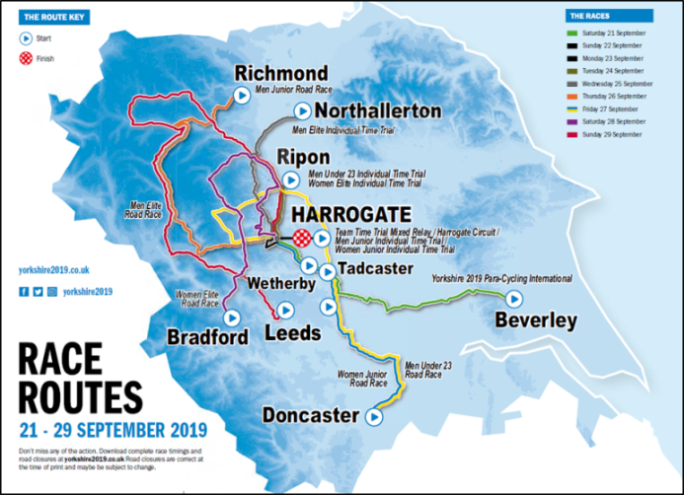
In September 2019 the world’s best cyclists will come to Yorkshire for the UCI Road World Championships, the pinnacle event in the international road cycling calendar. The Championships will include a range of men’s and women’s races, across age groups from junior to elite, starting in different towns and cities throughout Yorkshire and each finishing in the main competition town of Harrogate (please see right).

Harrogate will be the focal point for the Championships and host the finish of every race over the nine days of competition. Racing will take place throughout the 21st – 29th September 2019.
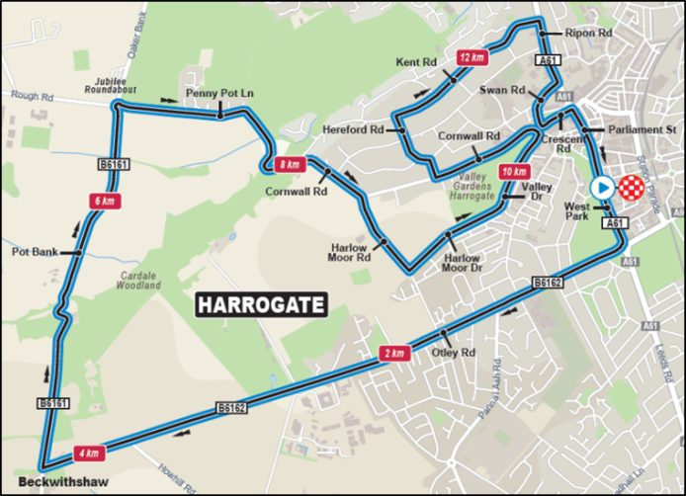
To find more details about each stage please view the official Yorkshire 2019 webpage by visiting https://worlds.yorkshire.com/
Throughout the week there will be both full closures and rolling road closures of parts of the circuit in Harrogate (please see left). There will be rolling road closures in place before, during and immediately after the race has passed and these are expected to last for around an hour.
Please check the websites below, for full details of the closures.

The race schedules for each stage of both the men and women's races are available at https://worlds.yorkshire.com/the-races/
Further details regarding road closures can be found on the North Yorkshire County Council website at https://www.northyorks.gov.uk/uci-road-world-cycling-championships
If you need an appointment with at your GP Practice during this time please allow sufficient time for travel as there will be some road closures.
You can also access information and advice from NHS 111 and your local pharmacy.
.

